**APRIORI Algarithm:**

|  |  |
| --- | --- |
|  |  |
| Support and confidence place a major role. Support gives us the no. of item sets that needs to be consider If support is 2 or more than 2 . if support is less than 2 then we need to ignore.  Confidence is 50%, in the final result we will get the confidence in percentages. If confidence is more than 50% then we wil consider the item set, otherwise ignore that item sets. | |
|  |  |
| Item set D,E, F got support of 1. But they given us the support=2. So we need to remove these item sets from the list. | |
|  |  |
|  |  |

Here we can not create candidate C3 because here only two item sets{A, C} so further we need to calculate support and confidence.

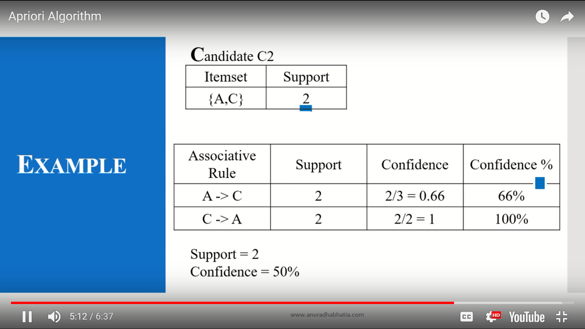

Here in confidence means 2/3 . 2 is the support 3 is the occurance of A in the candidate C1.

Here support and confidence both satisfied. So we design two associative rule for this particular transcation id.